Question 1
- Consider the following Diagram
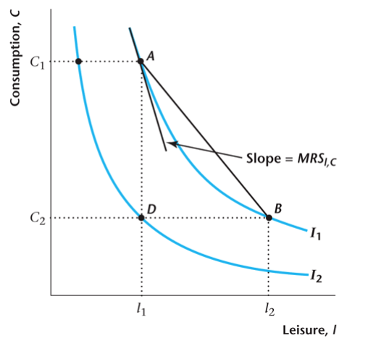
At point B, the consumer is consuming Blank 1 (more/less/equal) leisure than at point D, and Blank 2 (more/less/equal) consumption good than at point D
At point A, the consumer is consuming Blank 3 (more/less/equal) leisure than at point D, and Blank 4 (more/less/equal) consumption good than at point D
10 points

Question 2
- Consider the following Diagram.
The consumer prefers (strictly) A to B
True
False
10 points

Question 3 Consider the following Diagram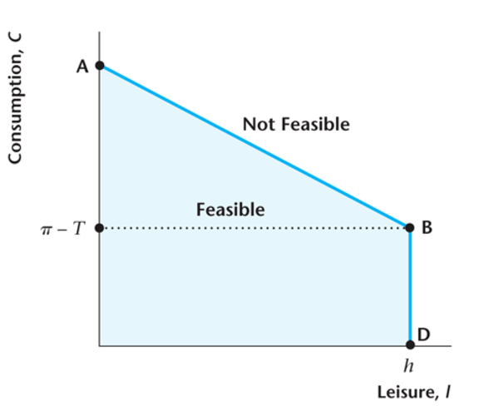
Suppose that the consumer chooses Leisure=h...
Choosing Leisure=h means that the consumer doens't work at all. It can afford to consume only because profits are greater than government transfers
Choosing Leisure=h means that the consumer works all the time, and so when Leisure=h the consumer can afford the highest level of consumption good
Choosing Leisure=h means that the consumer doens't work at all, and for this reason she can't afford any consumption good
Choosing Leisure=h means that the consumer works all the time, and for this reason she can afford any level of consumption good
10 points

Question 4
- Consider the following Diagram
The absolute value of the slope of the segment AB is...
The relative price of leisure (the wage) divided by the relative price of the consumption good - which is also called the real wage w
The relative price of leisure the consumption good divided by the relative price of leisure (the wage)
The profit from owning the firm
Government transfers
10 points

Question 5
- Consider the following Diagram
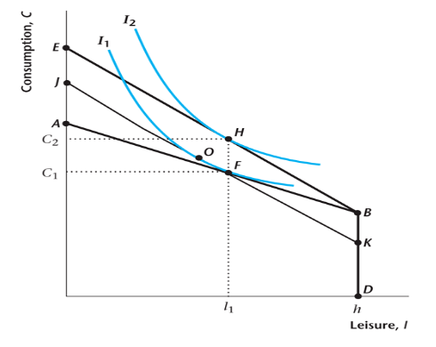
From this picture, you can see that...
The substitution effect (OF) dominates the income effect (OH), and leisure grows
The substitution effect (OF) is dominated by the income effect (OH), and leisure grows
The substitution effect (OH) dominates the income effect (OF), and leisure falls
The substitution effect (OF) dominates the income effect (OH), and leisure falls
10 points

Question 6
- Consider a production function Y=zF(K,N^{d})
What is z?
The capital input (machines, computers, etc)
Gross Domestic Product
The Labor Input (workers)
Productivity level or Total Factor Productivity
10 points

Question 7
- Consider a production function Y=zF(K,N^{d})
Which of the following properties we assume for F?
  - Constant returns to scale.
  - Output increases with increases in either the labor input or the capital input
  - The marginal product of labor decreases as the labor input increases.
  - The marginal product of capital decreases as the capital input increases.
  - The marginal product of labor increases as the quantity of the capital input increases.

1,2,3,4 and 5
1,2,3 and 4
1,2,3
Only 1 and 2
10 points

Question 8
- Consider the following diagram
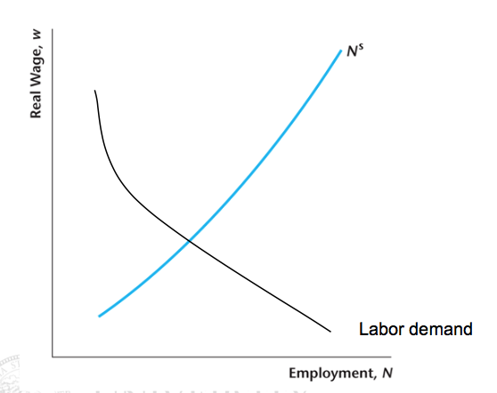
Suppose the income effect is dominated by the substitution effect, and government transfers T fall...which picture best represents what will happen?

 | a. | 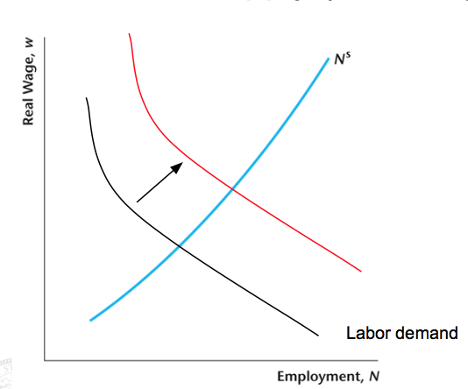
 | b. | Nothing will change
 | c. | 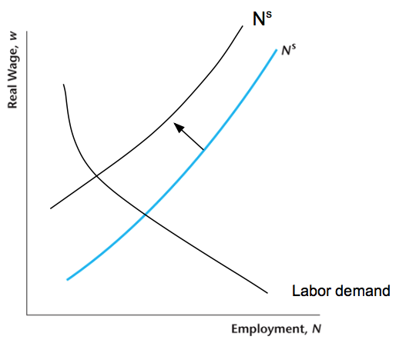
 | d. | 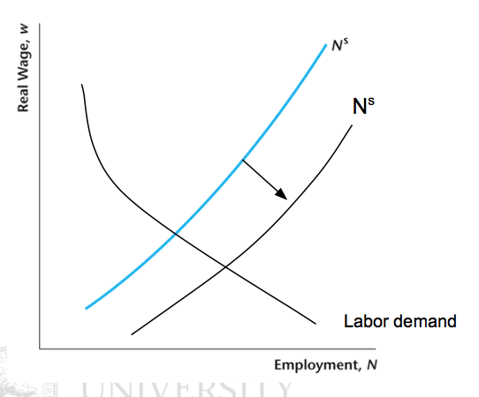
points

Question 9
- Consider the following diagram
Suppose the income effect dominates the substitution effect, and government transfers T fall...which picture best represents what will happen?

 | a. | Nothing will change
 | b.
 | c.
 | d.
10 points

Question 10
- Consider the following Diagram
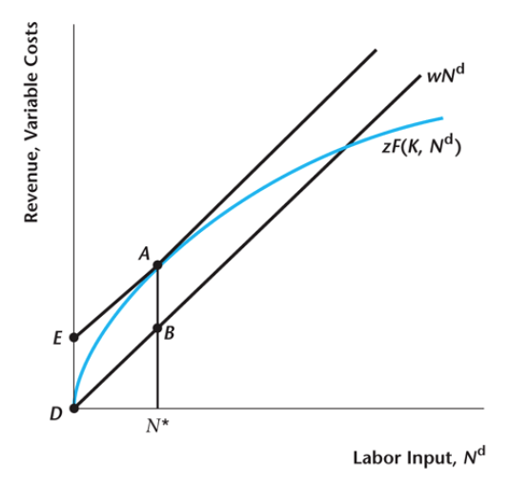
At point A...
The marginal cost (w, the market wage) is greater than the marginal benefit (the marginal product of labor). Profits are equal to AB, and they could get higher it the firm chose a lower level of labor
The marginal cost (w, the market wage) is lower than the marginal benefit (the marginal product of labor). Profits are equal to AB, and they could get higher it the firm chose a higher level of labor
The marginal cost (w, the market wage) is equal to the marginal benefit (the marginal product of labor). Profits are equal to AB, but they could get higher it the firm chose a lower level of labor
The marginal cost (w, the market wage) equals the marginal benefit (the marginal product of labor). Profits are equal to AB, and they are as high as they can be

